LAB REPORT实验报告
Lab Title | Common-line Argument |  |  |  | Lab No. | 10
Stud. Name | Jiang Yunxiang | Major | CST |  | Class
Student ID | 2022102330 |  | Date | 4/28
Lab description/objectives:
Write a calculator program calculator.c that accepts an arithmetic expression as command-line arguments, e.g. 22 + 33. The program should perform the corresponding calculation, and display the result: 22 + 33 = 55. There are 5 types of operations: 44 + 55 for addition; 44 - 55 for subtraction; 44 x 55 for multiplication; 44 / 22 for division; 44 % 33 for modulus.
The program should at least check if the correct number of arguments are passed. If not, it displays a usage message and exits.

Source code:
（Paste the source code here）
#include <stdio.h>
#include <stdlib.h>
#include <string.h>

int main(int argc, char* argv[]) {
if (argc != 4) { // check if the correct number of arguments are passed
printf("Usage: calculator operand1 operator operand2\n");
exit(1);
}

float num1 = atof(argv[1]); // convert first operand to a float
float num2 = atof(argv[3]); // convert second operand to a float
char* op = argv[2]; // get the operator

float result;

if (strcmp(op, "+") == 0) { // addition
result = num1 + num2;
}
else if (strcmp(op, "-") == 0) { // subtraction
result = num1 - num2;
}
else if (strcmp(op, "x") == 0 || strcmp(op, "*") == 0) { // multiplication
result = num1 * num2;
}
else if (strcmp(op, "/") == 0) { // division
if (num2 == 0) {
printf("Error: division by zero\n");
exit(1);
}
result = num1 / num2;
}
else if (strcmp(op, "%") == 0) { // modulus
if (num2 == 0) {
printf("Error: division by zero\n");
exit(1);
}
result = (int)num1 % (int)num2;
}
else { // invalid operator
printf("Invalid operator: %s\n", op);
exit(1);
}

printf("%g %s %g = %g\n", num1, op, num2, result); // display the result

return 0;
}

Program outputs:
（Paste the screenshot of program output here）
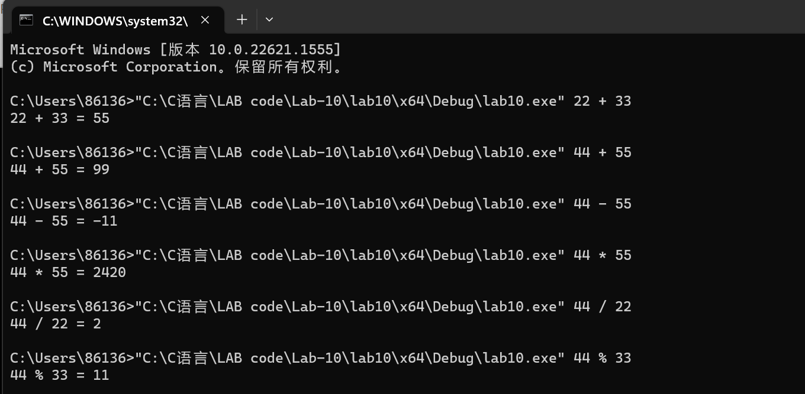
Discussion:
1．Most difficult parts
（What were the most difficult parts of your program to implement?）
Nope
2．Bugs and/or Errors
(List all the program bugs/errors you encountered and how you corrected them.)
Nope

